1. 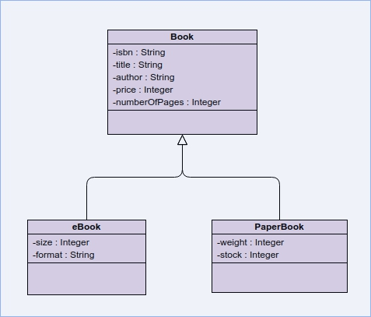Inheritance in object oriented programming is where a class, this class would be a child class, derived from a super-class where they share the same attributes and methods to form a hierarchy of classes. For example,

Association is a relationship between 2 classes that are independent of each other but may use the services the other provides. For example, a student may have 0 or many lecturers.

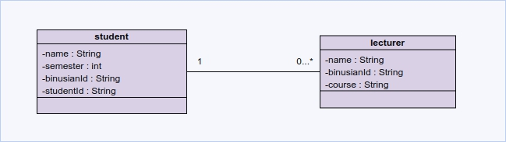Aggregation is where a class that may be made up of other classes. Where a class can exist by itself without necessarily be made up of another class. For example, a a car may have 0 to 7 passengers.

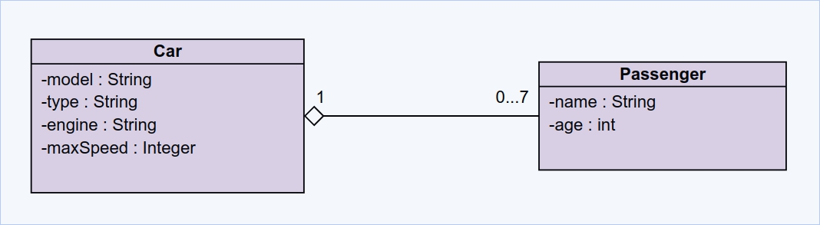Composition is where a class must be made up of another class or classes. The class can only exist if there are the other classes. For example a car needs to be composed of an engine.

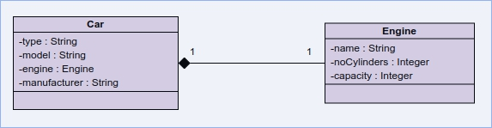

1. 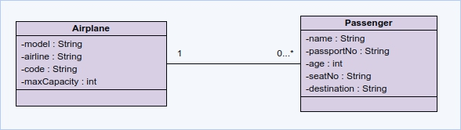Multiplicity is an active logical association between classes where cardinality is being depicted. Multiplicity is based on cardinality and participation where cardinality is the maximum number of possible relationships and participation being the least number of occurrences. For example, an airplane may contain at least 0 to many passengers.
2. 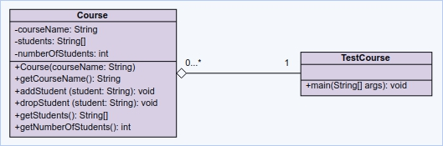Based on the book, I can create a class diagram as below where 1 TestCourse may contain 0 to many courses.

However, based on the code, i had to add and change a few things such as adding an extra operation in the class TestCourse and also changing students in course to be an ArrayList of String rather than an Array of String which will also change the operations getStudents() to have a return type of ArrayList of String. From this, I created a new class diagram as below.

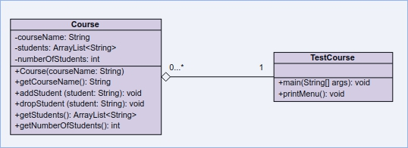I will attach the full code of the program with this file for convenience.